

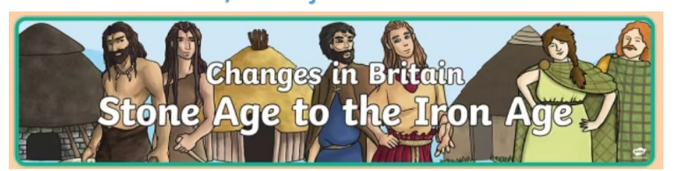

For our project homework this half-term, we would like children find out about Iron Age Hill Forts. Their research could be from books (maybe visit a library) or the internet.
To present your research your child could:
- Draw a diagram of a hillfort and label it.
- Make a 3D model of a hillfort. (Please ensure the models are reasonably sized for display purposes)
- Create a Powerpoint to share facts you have learnt.
- Create an educational or ‘guided tour’ video
- Write about Hillforts.
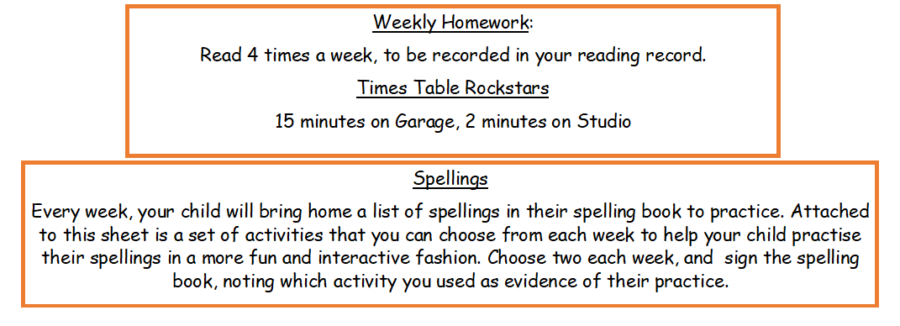
PE Days
Students come to school in their PE kit on the following days:
3J (Mr. Jones): Friday
3 S(Miss Spencer): Thursday
Project due Monday 19th October
Thank you for supporting your child with their homework,
Mr Jones Miss Spencer

