Dothill Friends Creative Competition
The friends would like to have a new logo that is striking, instantly recognisable & most importantly, one that has been designed by the pupils. You may want to include a swan or the school values. The winning design will then be used on all future friends’ letters and publicity etc.

How to Enter – Draw your logo in the circle above & hand your design to Mrs Butler on the gate. The closing date for entries is Friday 6th May.
Please remember that the logo should be simple and must be easy for us to reproduce. It will be reduced in size so needs to be large a clear. We look forward to receiving your entries!
Name |  | Class
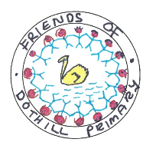
This is our current logo

